Executive Summary

2. System Request

Date of Request | Service Requested for Organization

Submitted By (key user contact) | Executive Sponsor (funding authority)
  Alexis Spence

Type of Service Request:
[ X ] New System
[ ] System Enhancement
[ ] System Error Correction
[ ] Other ____________________________________________________________________________

Brief Statement of Problem, Opportunity, or Directive

Brief Overview of Business Requirements

Brief Statement of Expected Solution

To Be Completed By Systems Priority Board
[ X ] Feasibility assessment approved  [ ] Feasibility assessment waived  [ X ] Request approved  [ ] Request delayed  [ ] Request rejected
  Assigned to
  Approved budget
  Start date
  Completion date
  Executive Sponsor Signature

Systems Priority Board Comments

3. Project Charter

Project Title | Tool Shed Hardware Store
Project Start Data | August 2021
Project Finish Date | November 2021
Project Budget
Project Manager | Dr. Joseph Cantanio

Project Overview

Stakeholders

Name | Role | Responsibility | Signature
Dr. Joseph Catanio | Project Manager | Coordinates all activities of project
Alexis Spence | Business Analyst

4. Functional Requirements

4.1 User Login / Registration

When a user tries to access the system, they must enter a username and password. If successful, they’ll get a message if it was accepted or not. First time users must create an account. The username must be unique in the system. The user will be prompted to create a password. If returning users forget their password there will be an option to retrieve it. There will be three security questions. The questions will be what city they were born, what was the make of your first car, and what is your mother’s maiden name. User will provide their answers to these questions. Once all this information is verified user will have access to the system.

4.2 Modify Account

Once logged into the system, a user can modify their demographic information and password. Prior to any changes, users must complete a 2-step verification process. Step 1 is that the user will have to provide an answer to one of the 3 security questions associated with the user profile. Once answered correctly, step 2 begins, and the system will send a 6-digit code via text message to both the phone number and email provided at registration time. The user must enter this code correctly to gain access to the system to modify their account profile. All changes are verified to adhere to company standards. For example, text-based profile data should only be text and not numbers or other characters.

4.3 Customer Order Product

The customer goes into the search bar of the hardware site. The customer then types in the item they want in the search bar. The site generates an item list that was personalized by the customer. The searched items go into the inventory information database. The item information that is specified to that exact item is then generated with its special ID. The customer then chooses that item to go into their cart on the website. When the customer processes their payment, it must be verified by the financial institution. If the credit card information is correct, then the payment will be successfully valid. The security handler also generates the payment to make sure it is successful.

4.4 Employee Product Order

Employees monitor the inventory and if low, they will place an order to refill the stock. The employee generates an order report of what needs to be refilled. If the order is approved, then the store inventory will be updated to the requested about the employee ordered. The employee will send the order details to their supervisor who will then approve or deny the order. The supervisor will then order the inventory that is needed if it is available. When the order is approved and ordered, the wholesaler will acknowledge the order. The requested items will then be collected from the wholesaler inventory. Once gathered, they will ship the items to the store along with a shipment confirmation. Within the confirmation, there will be a receipt that will go to the employee and the supervisor. When the order is received, the purchased inventory will then go to the employee to restock the inventory. When updated, the employee will fill all the backorders, if any.

4.5 Employee Order Status

The employee searches the customer order they want to check the status of. The customer order database releases the specific order. The system generates a unique order number. The unique order is then sent through the customer order status process. The order status is then sent back to the employee. The employee searches for the wholesale order they want to check the order status of. The wholesale company releases the order information to the searching process. The wholesale details are then sent to be processed through the wholesale information process. The wholesale order status information is then sent back to the employee

4.6 Customer Feedback

Customers can rate and provide a textual description on items provided they purchased the item. They can also provide similar feedback based on their buying experience, which implies they placed an order. The customer will select item(s) and / or their purchase order. They will then be prompted to enter their comments and star rating. Their feedback will be saved and marked as pending prior to acceptance of the feedback. Employees will review the textual descriptions for improper language and once approved will be viewable to other system users.

5.0 Process Models

5.1 Context Diagram

5.2 Level 0 Diagram

5.3 Level 1 Diagrams

5.3.1 User Login / Registration

5.3. 2 Corresponds to Modify Account

5.3.3 Corresponds to Customer Order Product

5.3.4 Corresponds to Employee Order Product

5.3.5 Corresponds to Employee Order Status

7.0 User Interface Model – Storyboard

7.1 User Login / Registration

7.2 Corresponds to Account Modify

7.4 Corresponds to Employee Product Order

7.5 Corresponds to Employee Order Status

7.6 Corresponds to Customer Feedback

8.0 User Interface Prototype Executable
Provide the name of your .exe file here and attach to D2L.

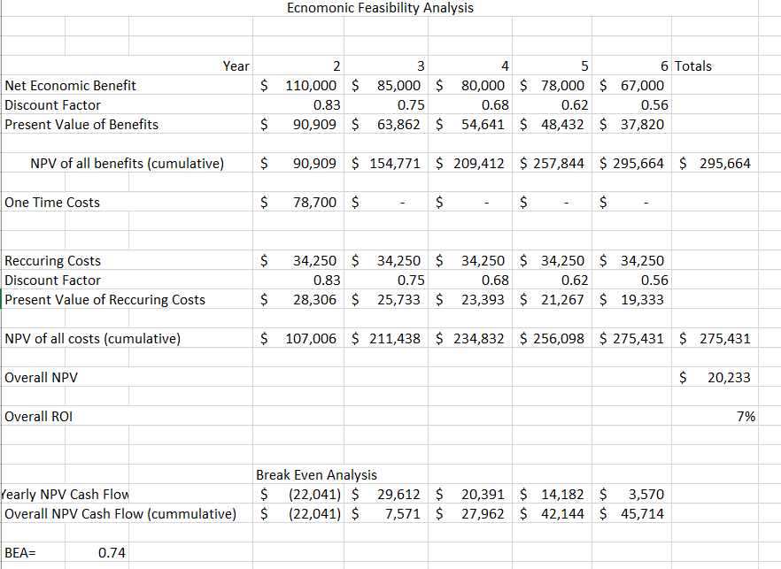
9. Economic Feasibility Analysis

9.1 One Time Costs Associated with Year 2

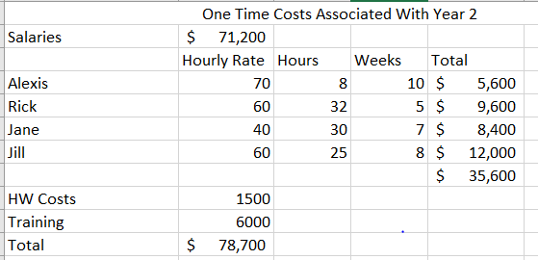

9.2 Recurring Costs Associated with Years 2 through 6

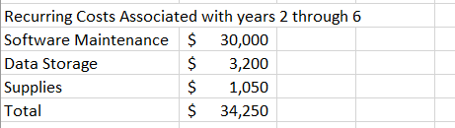

9.4 Break Even Analysis

10.0 Lessons Learned Report

What worked well?

What did not work well?

How to improve?

11.0 Student Resume
Attach resume here

